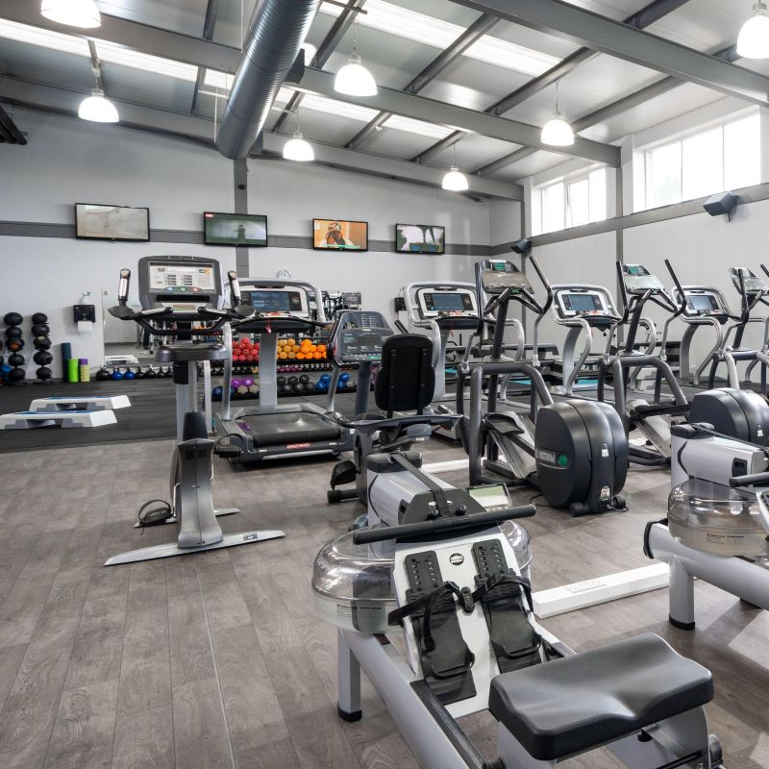

**MON**

**CIRCUITS**

9:30- 10:00AM

**YOGA**

9:30- 10:30AM

**CIRCUITS**

6:45- 7:15PM

**SPIN**

7:30- 8:00PM

**TUES**

**SPIN**

9:30- 10:00AM

**CIRCUITS**

10:15-10:45AM

**WATER AEROBICS**

11:00- 11:30AM

**SPIN**

6:00- 6:30PM

**KETTLEBELLS**

6:30- 7:00PM

**YOGALATES**

7:15- 8:15PM

**WED**

**KETTLEBELLS**

9:30- 10:00AM

**PILATES**

10:15- 11:15AM

**WATER AEROBICS**

11:00- 11:30AM

**SPIN**

6:30- 7:00PM

**CIRCUITS**

7:15- 7:45PM

**THUR**

**SPIN**

9:30- 10:00AM

**CIRCUITS**

10:15- 10:45AM

**WATER**

**AEROBICS**

11:00- 11:30AM

**YOGA**

6:30- 8:00PM

**CIRCUITS**

6:45- 7:15PM

**SPIN**

7:30- 8:00PM

**FRI**

**SPIN**

9:30- 10:00AM

**CIRCUITS**

10:15- 10:45AM

**HYBRID**

6:30- 7:15PM

**SAT**

**SPIN**

10:30- 11:00AM

**COUNTRY CLUB TIMETABLE 1st July 2024**

**SUN**

**CIRCUITS**

10:30- 11:00AM